**ADVT2509**

# **Pauls Milk Advertising Campaign Report Pitch**

Word count: around 2700

By

UQ Creative Advertising Company

Liam Buttery: 43531538

Man Shuen Pun: 44143657

Tan Sing Han: 44047193

Emily Campbell: 42938194

# 

### 

### **Table of contents**

1.0 Overview

1.1 Background of Paul’s Milk

1.2 Current Milk Market and the Rising of the Milk Alternatives

1.3 Campaign Objectives and Marketing Goal

2.0 Target Market

2.1 Target Group Justification

2.2 Consumer Insight

3.0 Creative Strategies

3.1 Massage Strategies

3.2 Rational Appeal

3.3 Executional Techniques

4.0 Media Selection and Planning

4.1 Television Advertisements

4.2 Print Media

5.0 Budget

6.0 Measurement and Evaluation

7.0 References

8.0 Appendix

Appendix A Australian Milk Production

Appendix B Relevance informations

Appendix C Comparison of Nutrient Components Between Milk and Milk Alternatives

Appendix D Print Media

Appendix E Television Advert Script

Appendix F Budget Flowchart

**1.0 Overview**

**1.1 Background of Paul’s Milk Company**

Pauls Milk has been making dairy products for more than 80 years and continues to support hundreds of Australian farming families. Owned by Parmalat, Pauls Milk is currently ranked as Australia’s number one milk and dairy brand (Aztec, 2016). Paul’s Milk leading the milk market, owning 18.3% of the Australian dairy milk market share.

**1.2 Current Milk Market and the Rising of the Milk Alternatives**

Milk consumption in Australia is higher than the majority of the Western countries. Figures from Dairy Australia indicate that the average Australian consumes 105 litres of fresh milk per year (McCarthy, 2016). However, the demand for milk alternatives such as soy, almond and oat are increasing and taking over the dairy milk market shares (IBIS world, 2016). It has became more popular to substitute full cream milk for milk alternatives amid health concerns. It is shown that the global market for milk alternatives reached $5.8 billion in 2014 and should reach nearly $10.9 billion by 2019, reflecting a five-year compound annual growth rate (CAGR) of 13.3% (Cumming, 2016). In addition, Pauls Milk has lost a total of 3.9% of revenue during 2016 (IBIS world, 2017). This situation has decreased the revenue of most dairy milk brands and is set to continue as the milk alternatives rise in popularity. In order to solve this problem of decreased revenue, an advertising campaign must be developed to increase the customer preferences towards dairy milk products.

**1.3 Campaign objectives and Marketing Goal**

Based on that identified problem, we have decided to pitch an advertising campaign that has three main advertising objectives. First, our advertising campaign aims to shift consumer preferences from alternative milk such as soy milk, almond milk and rice milk towards dairy milk products. An advertisement that is focusing on the benefits of dairy milk is crucial to shift the consumer perspective in favour of dairy milk. It is important to inform consumers about the benefits of dairy milk because so the consumers focus on dairy rather than alternative milk. Additionally, our advertising campaign will increase awareness that dairy milk is still the most nutritious among all types of milk (McCarthy 2016). This awareness will shift the market consumption back towards dairy milk products, in addition to increasing the sales of Pauls Milk products. Our third advertising campaign objective is to promote Pauls Milk as a highly reputable and trustworthy Australian brand. A good brand reputation will not only increase the sales of milk, but other products as well such as yogurt and custard. Having a reputable name will give Pauls Milk a competitive advantage over their competitors. As the brand reputation of Pauls Milk improves, market share of the company will rise, increasing the overall total revenue of the company.

Lastly, the marketing objective of our advertising campaign is to gain back dairy milk market share. This will be achieved by communicating the disadvantages of alternative milk and benefits of dairy milk to consumers. When favour shifts back to full cream milk, consumers will start boycotting alternative milk and instead purchase dairy milk products. This result will able to increase the profits of all dairy milk brands, benefitting Pauls.

**1.4 Zero-based planning**

Zero-based planning was used in developing this campaign. First, we identified the target audiences. Through a SWOT analysis of Pauls, we focused on the strengths and opportunities to develop our creative strategies to meet our determined objectives (see fig.1.). Following this, we determined the budget and identified a process to evaluate the campaign effectiveness.

Figure 1. SWOT analysis of Pauls Milk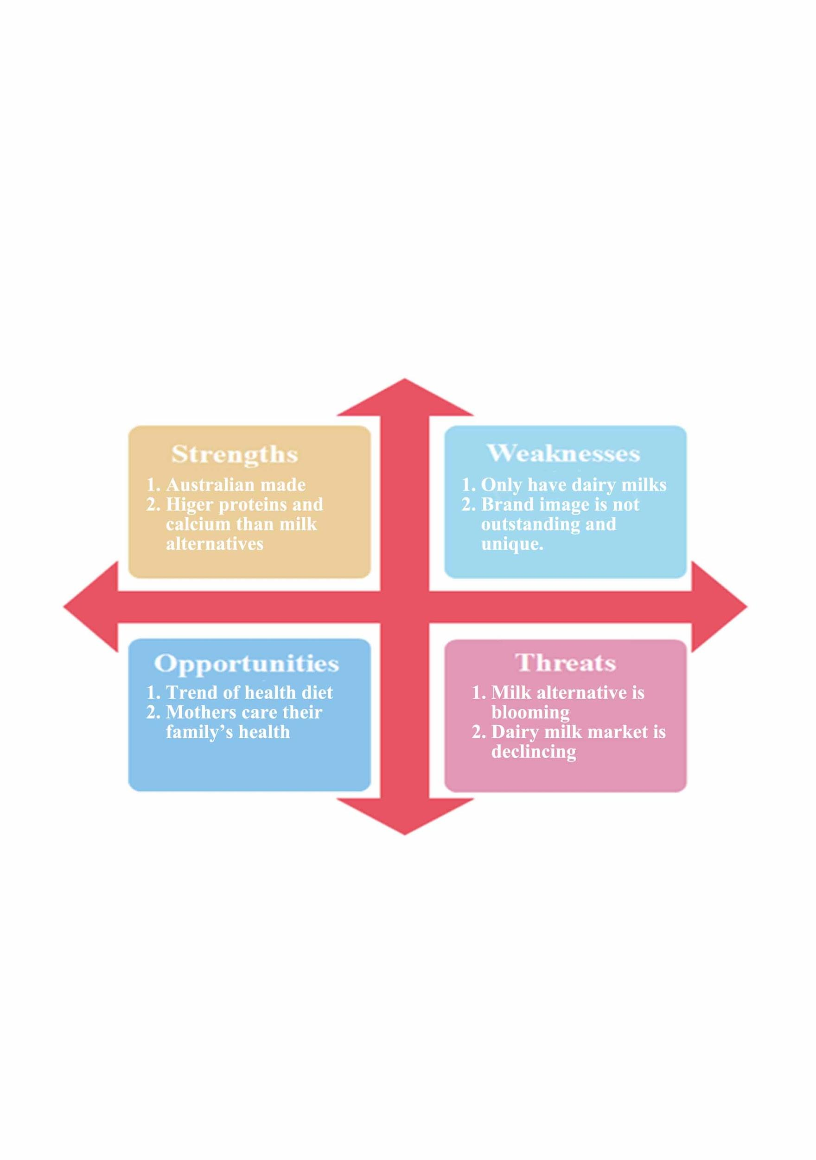

**2.0 Target Market**

**2.1 Target groups justification**

With our client company, Pauls, we have decided to limit our target groups to females, specifically to females who have children. Females tends to put more consideration into grocery shopping than males, who appeared to spend less time selecting goods (Mortimer, & Clarke, 2011). With our campaign focusing on comparing Pauls milk with alternatives and reinforcing its healthiness, it is more effective to aim at females as they will be inclined to put the effort into selecting brands. A research survey on Australian grocery shopping habits revealed that mothers are still more likely to shop for the family than fathers, while men and women have the equal possibility to do the groceries when they live alone with no children (Australian Food News, 2015). Hence, we further limited our target group to women with children, including both working mothers and housewives.

**2.2 Consumer insight**

With our advertising campaign aimed at Australian mothers, the insight is their core belief of the importance of family. Advertising will be effective when it appeals to the consumer insight, so as to motivate them to purchase the product. Mothers are generally concerned with providing their family members ingredients for a healthy diet (Hart, Damiano, Cornell & Paxton, 2015; Fruit Heroes 2015). At this stage, it is clear that Australians preference has shifted from full cream milk to modified milks (Dairy Australia n.d.). Besides that, the milk alternative market is booming because of their so called ‘health benefits over dairy milk’ (Cumming 2016). It is obvious that mothers are increasingly concerned with maintaining a healthy diet and adopting new health food trends. A reason for this is because they love their family and strive to keep them healthy. With milk alternatives labelling themselves a healthier option than dairy, many consumers believe their claims and choose to buy milk alternatives over full cream dairy milk. However, our campaign will use similar techniques of reinforcing the health benefits of full cream milk to shift consumer preference back to dairy. Since concern for family is the main consumer insight for our target audience, the fact that full cream dairy milk is more nutritious than milk alternative substitutes will be stated in our television advertising (see Appendix C). It will also be mentioned that many milk alternatives do not meet the recommended daily intake for protein and calcium. Full cream milk remains the most nutritious, while the benefits of lower fat and kilojoules in milk alternatives, result in lower protein and calcium contents than dairy milk (McCarthy, 2016). By informing our target audiences that only full cream milk can provide enough protein and calcium, we are appealing to the consumer insight of prioritising family health and consumers will choose dairy milk over milk alternatives.

**3.0 Creative Message and Strategies**

**3.1 Message Strategy**

Formulating the right message strategy is extremely important to this advertising campaign. It is crucial to exercise the message consistency on what the company want to convey with what it does and what other people think about it. Our chosen target audience will consider the nutrition benefits when they shop for the whole family, especially within the context of the eating a healthy diet (Watson 2015; Bhagat 2016). Parents are generally concerned with providing a healthy environment for their children (Hart, Damiano, Cornell & Paxton, 2015; Fruit Heroes 2015). Pauls Milk products are all Australian made and contain rich proteins and many other more nutrients than milk alternatives (Appendix C). The major selling argument for this campaign will be that Pauls milk is healthier than other milk alternatives as it meets recommended daily nutrition requirements for adults and children. In order to convey this, two message strategies will be used: positioning and creating brand image.

Pauls milk positions themselves as a superior product by reinforcing its nutritous quality and dependability over competitors. For quality, Pauls dairy milk is rich in protein and calcium. The dairy farmers supplying Pauls are Australian and since it is local, the whole production process is monitored and regulated by the Australian government. Through this, it builds a safe and reliable brand image that Pauls milk is a local company who provide the best product for Australian citizens. Pauls care about their consumers as all the procedures are traceable, unlike some milk alternatives where consumers do not know where the raw ingredients are imported from. Even if they do know, consumers cannot be guaranteed the quality of the raw materials if they have been produced outside Australia with a lower quality control and food safety standards. Pauls milk is more than just a milk company; it is a brand image of credibility and trustworthiness. This brand image will be developed through our television advertisement as Michelle Bridges will be our spokesperson to endorse the quality of Pauls milk. Her credibility as a high-profile personal trainer and authority in the field of nutrition and fitness are widely respected in Australia. Michelle Bridges is a mother to a young son and has published healthy cookbooks and even a 12 Week Challenge dietary and fitness regime. Our target audience will respect her endorsement of Pauls full cream milk and be influenced to buy the product, given Michelle’s reputation as a mother who is concerned with her health and that of her young family. She will reinforce the importance of protein and calcium levels found in Pauls milk to a balanced, nutritious diet compared to levels found in milk alternatives. Therefore, we are positioning Pauls as superior to its milk alternative competitors.

**3.2 Rational Appeal**

By positioning Pauls milk as a brand that values the quality and dependability of our products, we are using rationality-based appeal. Rational appeal focuses on the practical and functional needs of customers and emphasises the unique benefits of using our products. The advertising campaign will persuade audiences by using informative message strategies of health and safety concerns. Pauls milk is nutritionally superior to milk alternatives as it contains higher levels of protein, calcium and vitamins. From a health perspective, it is better to choose Pauls full cream milk. Unlike most milk alternatives, all Pauls milk is produced within Australian. It is completely safe as every single procedure and raw ingredient is traceable and milk processing procedures meet strict Australian standards. Rational appeal shows our target audience that Pauls milk is a healthy product and reliable company, concerned with the health and safety of its customers.

**3.3 Executional techniques**

In order to demonstrate the rational appeal, the following creative executions will be used: straight sell, comparison and celebrity endorsement executional techniques. Evidence shows that Pauls full cream milk has more protein and calcium than milk alternatives. The production of Pauls Milk will be emphasised in both print media and television to reinforce that Pauls milk is 100% Australian made, assuring audiences that our milk is reliable and safe. Based on this information, it is more beneficial to purchase Pauls milk instead of milk alternatives. Pauls milk product information and production process will be explained in a straightforward manner through our television advertisement featuring Michelle Bridges. Celebrity endorsement techniques help build public consensus due to Michelle’s credibility in the fitness industry. Michelle is famous for her nutrition expertise, and is a respected household name. She is also a new mother who is concerned with providing a healthy diet for her son, which target consumers will sympathise with. In the ad, Michelle will state the factual information about Pauls milk and reinforce its benefits compared to milk alternatives in a family conversation setting. Michelle Bridges’ endorsement will ensure the quality of Pauls milk products are further reinforced.

Figure 1. Creative Strategies

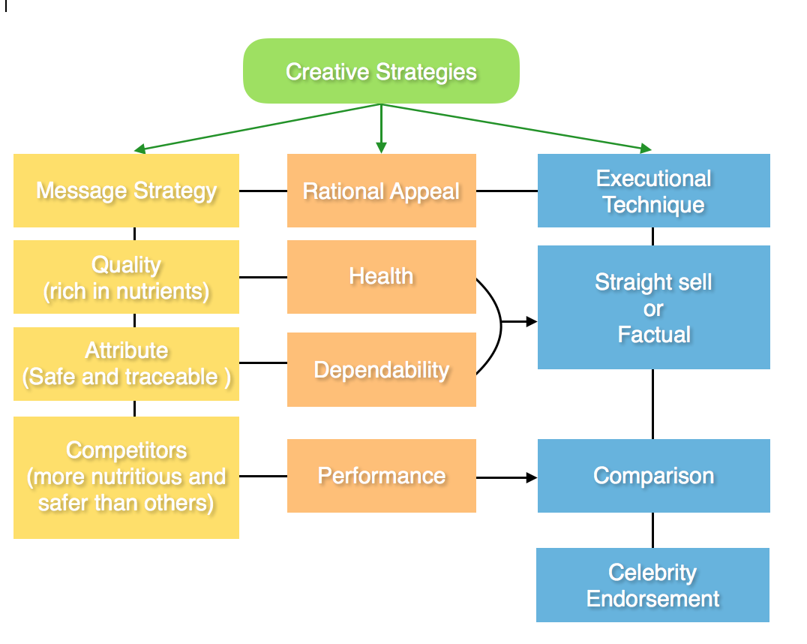

**4.0 Media Selection and Planning**

**4.1 Television advertisements**

Television was chosen as it provides wide reach and coverage, while utilising sight, sound and motion. There is a concern that TV ads may not be effective as high exposure does not necessarily mean high engagement. Audiences may not pay attention to the ad. However, for our campaign promoting dairy milk, it does not require high engagement since milk is only a ‘simple sale’. The whole purpose of TV ads is to emphasise Pauls milk is high-quality, dependable and better than milk alternatives, and loop these ideas into the consumer's head. The expectation of this ad is when consumers step into the milk aisle to make their selection, they can recognise our brand and find it familiar.

Another problem with TV ads is that it does not guarantee the message will be delivered to your targeted consumers. With the appropriate time slot of the ad, this disadvantage can be minimised. We identified the television shows our target group are most likely interested in, and broadcast our ad in that specific period to maximise the reach. A 30 second ad will run during breakfast shows, like Sunrise. More than 4 million viewers each week regularly watch the last five minutes of the show (Dunk, 2015). Morning shows are a good option not only because of their enormous audiences, but because milk is generally consumed as part of breakfast. It is very likely that mothers are having breakfast with their children. In addition to mothers, whoever is watching the show can be our potential consumers and be part of the high exposure television ad.

Michelle Bridges will be the spokeswoman for the ad to associate the brand with a respected celebrity personality. Michelle has name recognition and has created a 67 million dollar empire that includes dieting programs, cooking books and a fashion partnership with Big W. (AFR Weekend, 2013). Many people purchase and follow Michelle Bridges diets and cooking books(AFR Weekend, 2013). She is a symbol of healthy mothers and will bring a positive personality to the brand. She practices a healthy and proactive lifestyle. Since Michelle is a mother, she can connect to other mothers on a more personal level.

**4.2 Print Media**

In conjunction with the broadcast advertisement, a print media campaign will be run. Poster advertisements were chosen for their high repetition and strong impact. The print media will consist of a poster that will be placed on bus stops and the sides of buses. As milk is a simple sale, there is not much thought that goes into the purchase and it is readily available at supermarkets. This strategy aims to get as many eyeballs on the advertisement as possible to plant the brand image into the minds of public transport commuters and others driving in traffic. This is not a targeted segment of the campaign but will provide an extra means of getting the public's eyes on the campaign and maximise exposure.

In addition to this, the same poster will be displayed in women's focused magazines such as Good Health and Women’s Weekly, which have readerships in excess of 237 thousand and 1.6 million people respectively (Bauer Media, n.d.). These magazines published monthly, are targeted at mothers and always have a cooking/recipe section inside. This is where the print media campaign is directed at mothers specifically.

Both of these major advertisements link to our proposed creative strategies and fulfil our objectives by

* Reinforcing the health benefits of Pauls full cream milk
* Showing that it is 100% Australian farmed dairy products
* Addressing that it is a product suitable for the nutrition of the whole family
* Positioning Pauls as a desirable and trustworthy brand
* Reinforcing that full cream milk is healthier than milk alternatives

**5.0 Budget**

Based on our discussion, we have decided to use ‘top-down’ budgeting to limit the spending of our advertising strategies. The top management has sets the spending limits of our campaign to 1 million dollars. First, we decided to use our part of our budget on printing media, which are Women's Weekly and Good Health. This campaign will cost us $30,000 per week for 3 months, which is a total of $360,000. Next, we will spend $300,000 on TV advertising with the contract with ADAD company. Based on the contract, we will be broadcasting our advertisement in channel 7, 9 and 10. Furthermore, we will spend $40,000 for Bus & Bus shelters advertisements. Based on the price list, bus advertisement costs $1,250 per week and bus shelters cost $2000 AUD per week. Therefore, it is a total of $700,000 for the 3 month campaign. After 3 months, the company can organize a roadshow in city to create more awareness towards the benefit of dairy milk. This roadshow can last for 3 months and costs about $300,000. (see Appendix F for budget flowchart)

**6.0 Measurement & Evaluation**

After 3 months of our campaign, we decided to create a focus group to identify the effectiveness of our campaign. In the focus group, we will identify their preference between alternative milk and dairys milk. Not only that, we will identify the brands of dairy milk that they prefer, which determines whether there is an increase in positivity of brand image for Pauls milk as a result of the campaign. Finally, we will ask the audience about their knowledge of the advertisements during the Pauls campaign, including whether they have seen it or if it changes their perspective towards dairy milk. As well as focus groups, we will conduct a survey to identify the customer preferences and their perspective and awareness towards the benefits of dairy milk. Surveys with a combination of open-ended and close-ended questions can also improve the understanding of audiences towards the benefits of dairy milk and attitudes towards Pauls.

Finally, we will perform an analysis of the current sales of Pauls milk to evaluate the effectiveness of the campaign towards the sales of the product. Part of this will be measuring the numbers of people that prefer dairy milk to alternative milk. Ultimately, this analysis, will allow us to measure the effectiveness of the campaign and achieve a high return on investment in Pauls Milk company.

**7.0 References**

ABC Health and Wellbeing. 2014. ***Q: Do soy foods increase your risk of cancer?***,[Blog post], Australian Broadcasting Corporation, June 02. Accessed online http://www.abc.net.au/health/talkinghealth/factbuster/stories/2014/06/02/4017020.htm. Viewed May 29, 2017.

Australian Bureau of statistics. 2016. ***4364.0.55.012 - Australian Health Survey: Consumption of Food Groups from the Australian Dietary Guidelines, 2011-12,*** [Media release], May11. Accessed online http://www.abs.gov.au/ausstats/abs@.nsf/Lookup/by%20Subject/4364.0.55.012~2011-12~Main%20Features~Milk,%20yoghurt,%20cheese%20and%20alternatives~17 . Viewed May 28, 2017.

AFR, 2013. ***Michelle Bridges’ empire of body transformation***. Accessed online http://www.afr.com/business/media-and-marketing/michelle-bridges-empire-of-body-transformation-20140123-jysoq . Viewed on May 28, 2017

Australian Food News. 2015. ***Research survey reveals more Australian grocery shopping habits***, [Media release], May 18. Accessed online http://www.ausfoodnews.com.au/2015/05/18/research-survey-reveals-more-australian-grocery-shopping-habits.html . Viewed on May 30, 2017.

Aztec Fresh White Beverages and Soft Dairy National Volume MAT 14/02/16

Bauer Media Group, n.d. ***The Australian Women’s Weekly At A Glance***. Accessed online <http://www.bauer-media.com.au/brands/the-australian-women-s-weekly/>. Viewed May 18th, 2017.

Bhagat, A. 2016. ***A Little Is A Lot: Health and Wellness Trends 2016,*** [Blog post], July 3. Accessed online http://www.huffingtonpost.com/alisha-bhagat/a-little-is-a-lot-health-and-wellness-trends-2016_b_9393638.html . Viewed May 28, 2017.

Cumming, S. 2016. ***Got Plant-Based Milk? Milk-Alternatives Market Booming, Reports BCC Research***, [Media release], BCC Research LLC, April 06. Assessed online http://www.marketwired.com/press-release/got-plant-based-milk-milk-alternatives-market-booming-reports-bcc-research-2112301.htm . Viewed May 29, 2017

Dairy Australia. N.d., ***Drinking milk sales,*** [Media release].Accessed online http://www.dairyaustralia.com.au/Markets-and-statistics/Production-and-sales/Milk/Drinking-Milk-Sales.aspx . Viewed May 28, 2017.

Dunk, T. 2015. Sunrise vs. Today: Why is the battle for breakfast so bloody? ***News.com.au***, April 10. Accessed online at http://www.news.com.au/entertainment/tv/morning-shows/sunrise-vs-today-why-is-the-battle-for-breakfast-so-bloody/news-story/6fd5a58d4ff5a0d21e0567691bb82526. Viewed on May 30, 2017.

Evans, S. 2016. Parmalat Australia profits rise as dairy rivals stumble, ***The Sydney Morning Herald***,May 16. Accessed online http://www.smh.com.au/business/parmalat-australia-profits-rise-as-dairy-rivals-stumble-20160513-gouf6a.html . Viewed on April 20, 2017.

Fruit Heros. 2015. ***84% OF BRITISH PARENTS ARE CONCERNED ABOUT THEIR CHILDREN’S DIET,*** March 23. Assessed online http://fruitheroes.co.uk/2015/03/84-of-british-parents-are-concerned-about-their-childrens-diet/ . Viewed on May 28, 2017.

Hart, M. L., Damiano, R. S., Cornell, C., & Paxton, J. S. 2015.What parents know and want to learn about healthy eating and body image in preschool children: a triangulated qualitative study with parents and Early Childhood Professionals. ***BMC Public Health,*** 15:596.

IBISWorld, 2017, ***Major Companies****.* Accessed online <http://clients1.ibisworld.com.au/reports/au/industry/majorcompanies.aspx?entid=94#MP7188> . Viewed on April 20, 2017.

McCarthy, M. 2016. Plant-based alternative milk consumption growing in Australia as dairy industry holds firm. ***ABC News***, October 25. Accessed online at http://www.abc.net.au/news/2016-10-22/australians-slowly-turning-to-alternative-milks/7949890 . Viewed on May 29, 2017.

Mortimer, G., & Clarke, P. 2011. Supermarket consumers and gender differences relating to their perceived importance levels of store characteristics. ***Journal Of Retailing And Consumer Services***, *18*(6), 575-585.

Watson, D. E. 2015. ***Younger Consumers Are Trending Toward More Health-Conscious Eating,*** [Blog post], April 10. Accessed online http://www.huffingtonpost.com/elwood-d-watson/younger-consumers-are-tre_b_6632166.html . Viewed May 28, 2017.

**8.0 Appendix**

Appendix A- Australian Milk Production

Australian milk production declined approximately 190 million litres, or 2.0%, to 9.54 billion litres in 2015/16 – reflecting both difficult seasonal conditions as well as the sudden price step-downs late in the season. Although seasonal conditions were initially favourable, a dry Spring and delayed Autumn break across much of the southeast increased input costs and constrained production. Consequently, national milk production was already down 1.1% YTD before late season step-downs were announced in April.

Milk production is concentrated in the temperate zone of Australia. Australian milk production remains strongly seasonal in the key south-eastern dairying regions, reflecting the predominantly pasture-based nature of the industry.

Milk production peaks in October, tapers off until late-summer, and then flattens out into the cooler winter months. The production of long shelf-life manufactured products in these parts of the country has enabled maximum milk utilisation within the seasonal cycle. However, the seasonality of milk output in Queensland, New South Wales and Western Australia is much less pronounced, due to a greater focus on drinking milk and fresh products in these states. Farmers in these states manage calving and feed systems to ensure more even, year-round milk production.

Appendix B Relevant Statistics

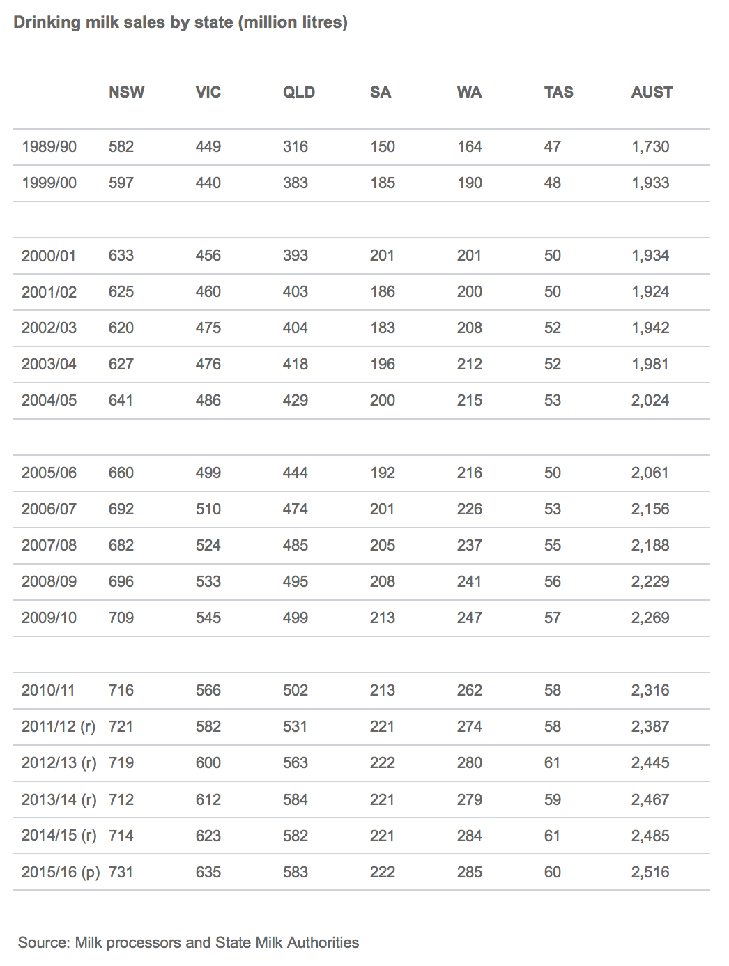

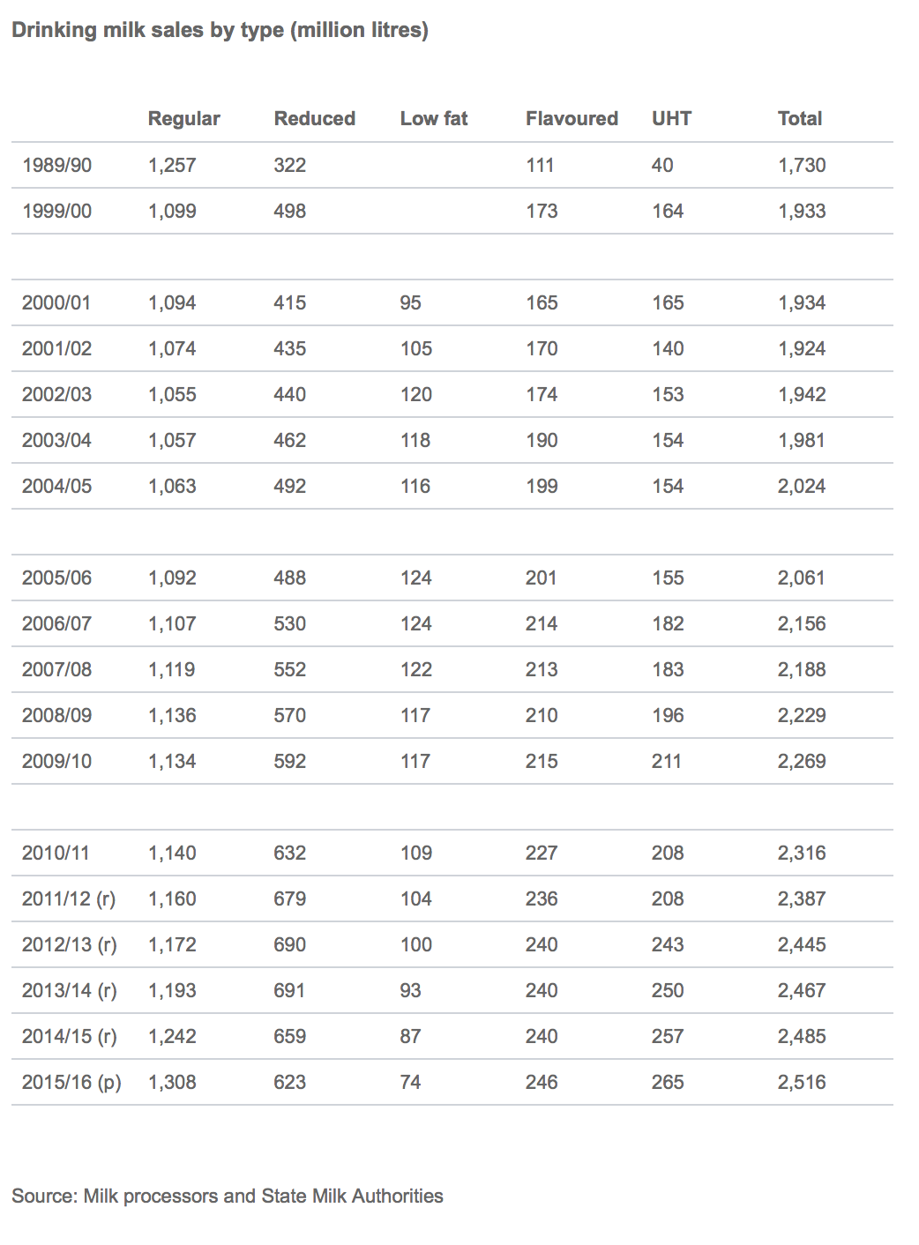

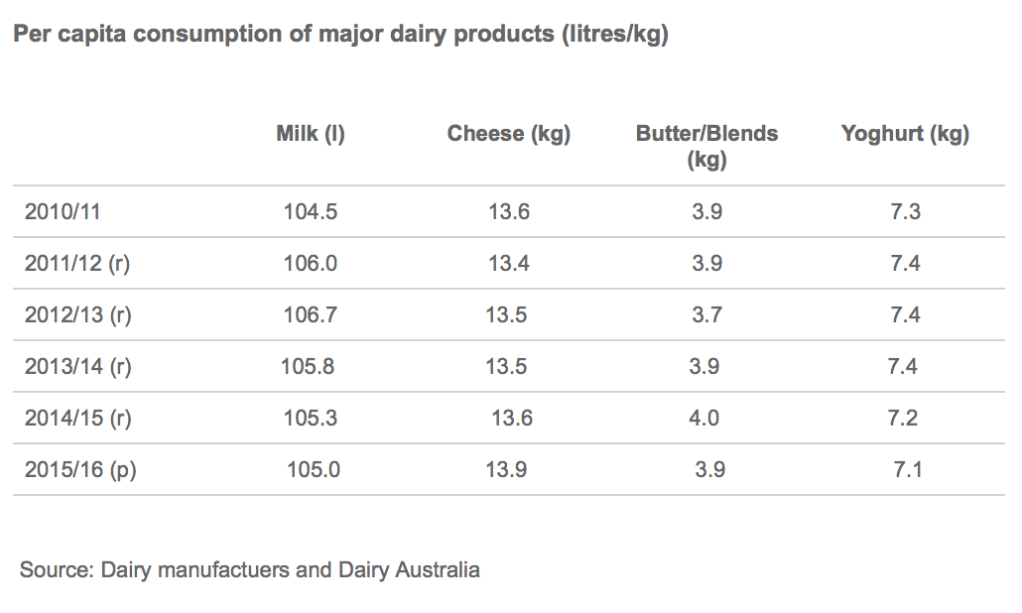

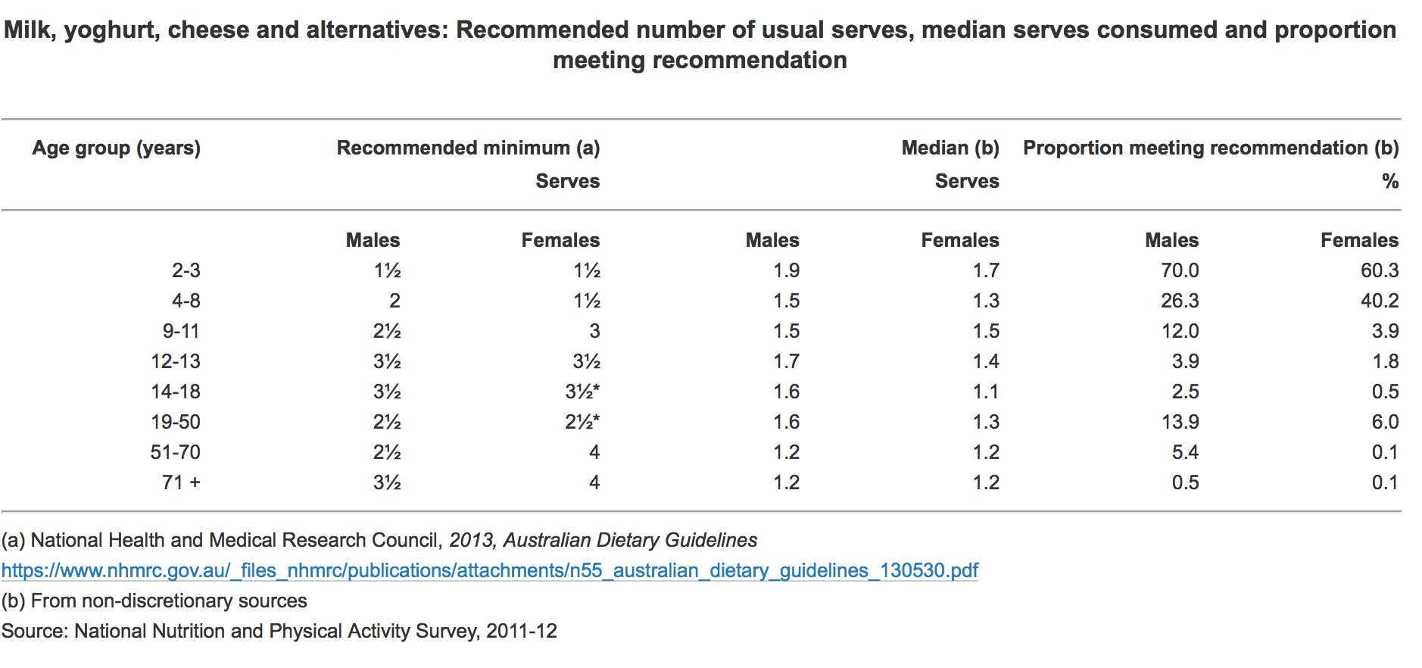

Appendix C Nutrient components comparison between milk and milk alternatives

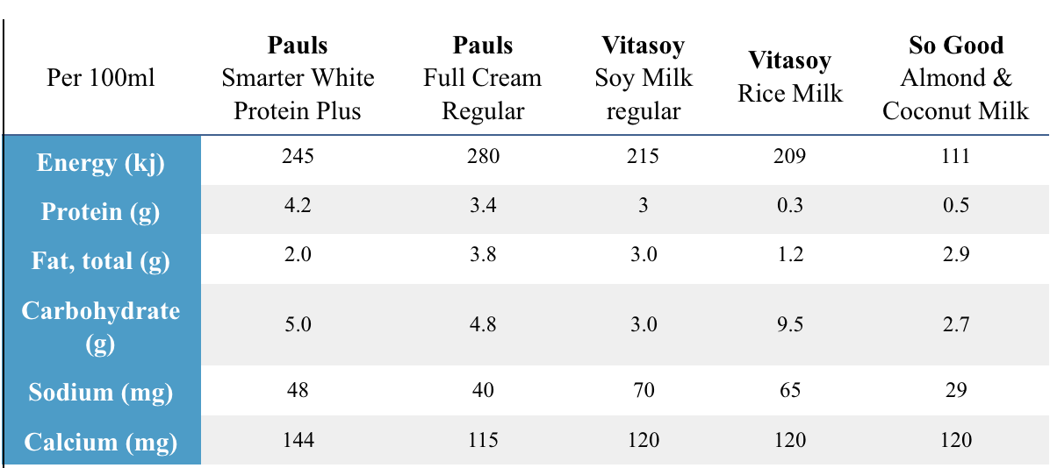

Source: Pauls, Vitasoy, and So Good's official websites.

Overall, Pauls milk has the highest protein and calcium among other milk alternatives.

Appendix D Print media

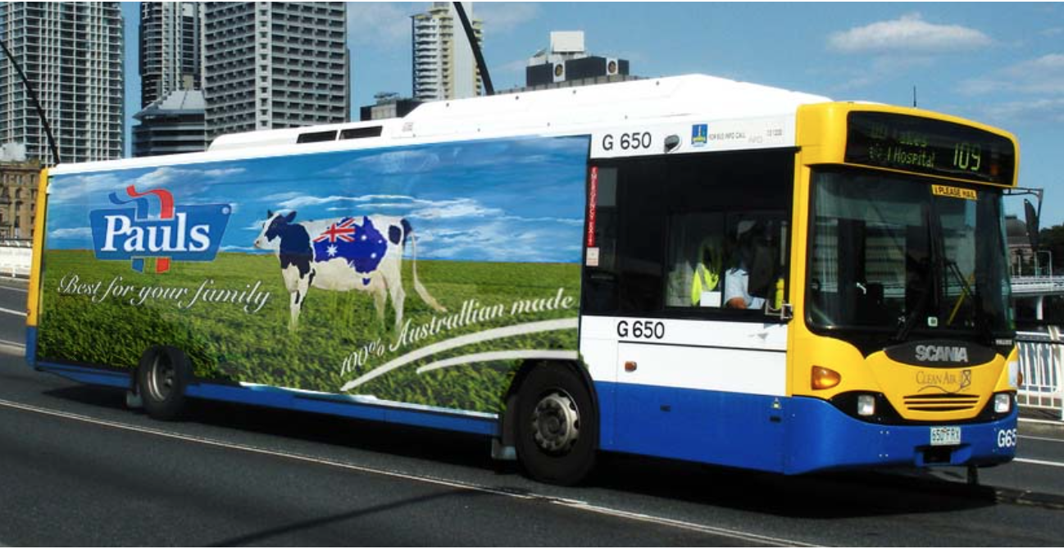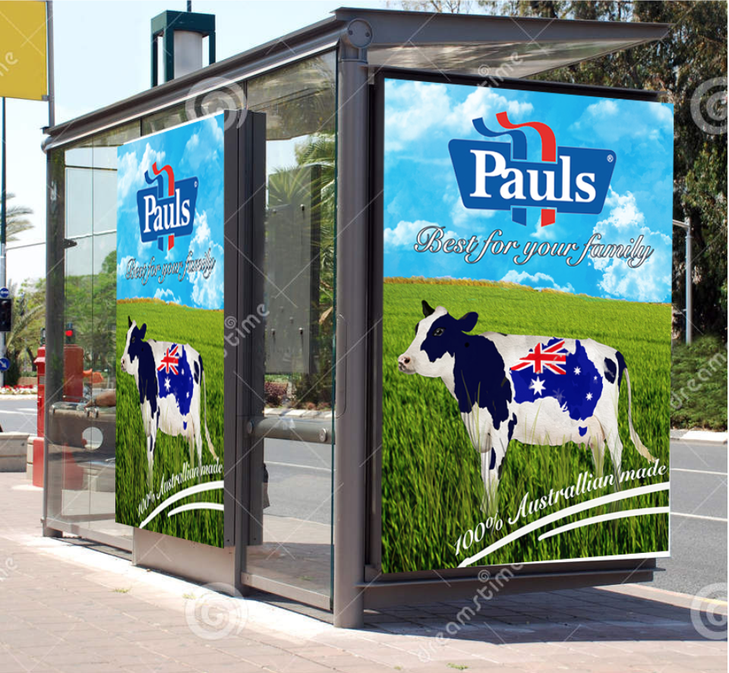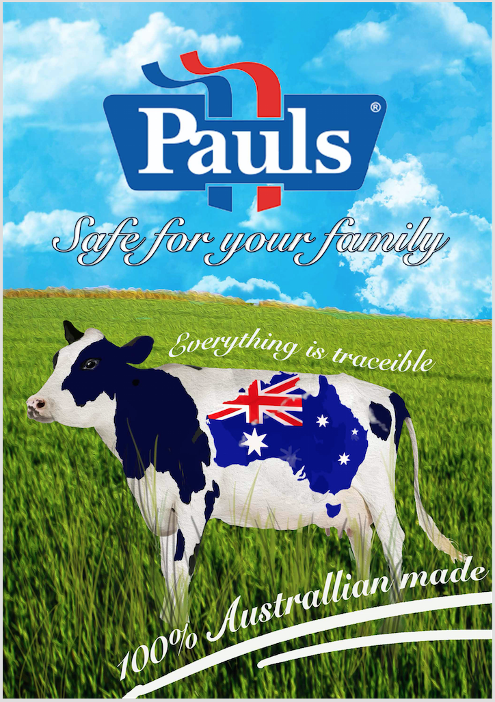

The poster features an image of a dairy cow looking content in a lush green pasture to demonstrate that the freshness of the milk and that dairy cows Pauls farmers use are healthy and well cared for. We have included a map image of Australia on the cow’s hide to reinforce to consumers that all Pauls milk comes from Australian dairy farms and local cows. Text reading ‘Best for your family’ sits under the Pauls logo to reiterate that a priority of Pauls is to provide quality dairy for Australian families. The poster is simple but aesthetically appealing and sends a persuasive message to consumers to choose Pauls milk.

Appendix E: Televison Ad Script

*(Opens with camera shot of Michelle Bridges in her kitchen with a blender full of fruit and yoghurt in front of her. 2L bottle of Pauls full cream milk next to blender on the bench. Camera films Michelle opening lid on bottle of milk, smiling, and adding some to the blender).*

Michelle: “Calcium and protein are essential to a healthy, balanced diet. Pauls full cream milk contains a huge variety of vitamins and minerals that your body needs to function at its best.”

*(Michelle switches blender on and camera cuts to zoomed in shot of the blender for about 5 seconds. Cuts back to Michelle who stops blender and pours herself a delicious looking smoothie into 2 glasses)*

Michelle: “Pauls are all about family. They began making dairy products for Australian families over 80 years ago, and continue to support hundreds of our Aussie dairy farming families today. Their creamy, smooth, flavoursome full cream milk is 100% Australian farmed, nutritious and tasty.”

*(Michelle picks up both smoothies and camera follows her walking to breakfast table, where her husband Steve ‘The Commando’ Willis is seated next to her son Axel in a high chair. She places a smoothie in front of Steve who smiles and begins to drink, then sits opposite him with her smoothie. Michelle grabs an empty sippie cup in front of Axel and fills it with Pauls full cream milk bottle from the table)*

Michelle: “Full cream milk is so versatile, and even the fussiest of eaters will love it. Use it on your cereal, in a breakfast smoothie, or any other ways you can think of.”

*(Axel picks up his sippie cup, smiling, and begins to drink his milk. Michelle smiles at him and takes a drink of her smoothie)*.

Michelle: “There are no substitutes for fresh Australian full cream milk, which is why my family choose Pauls. Alternative milks just don’t cut it when it comes to taste or nutrition. Put your family and their health first by choosing Pauls milk when you shop.”

*(Camera shot of family eating at table to finish, then cut to a still image of Pauls milk logo on 2L bottle)*

Appendix F budget flowchart

